The Old House Guild of Sandusky
  - Summer 2023 News for members 419-627-0640

Annual Spring Dinner
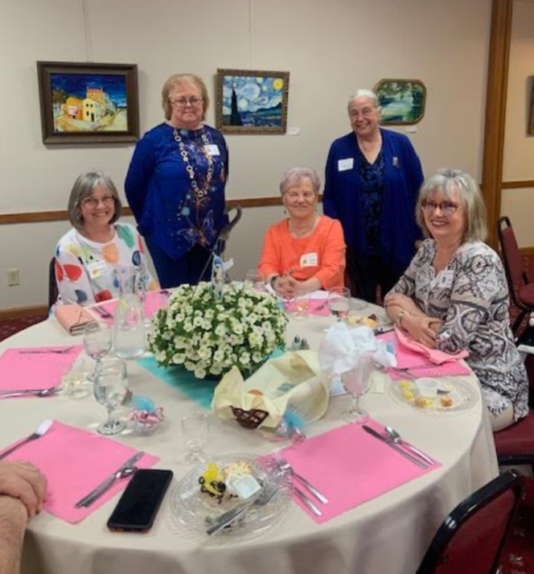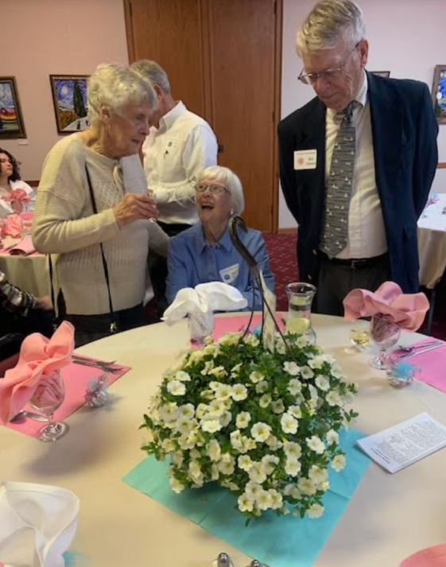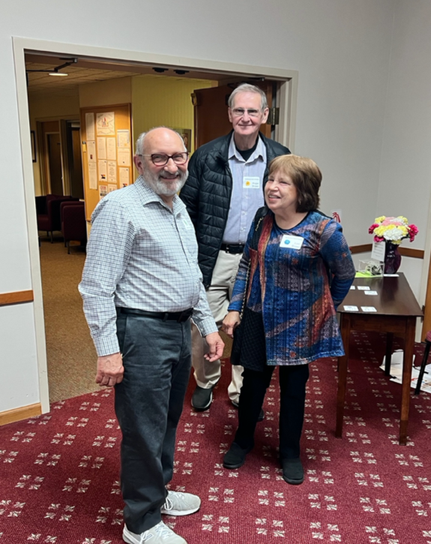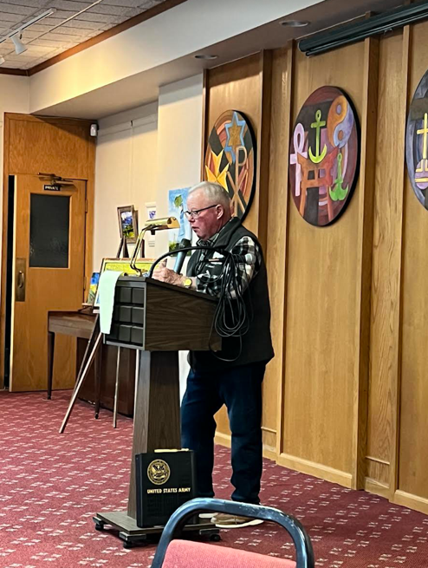

Summer 2023 News for Members Page 2
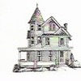
Message from OHG President
Dr. Richard Keller
Update on the Cooke-Dorn Preservation
Many of you are aware of the exterior repair work being performed at the Museum. This involves the replacement of stucco coating and tuckpointing of limestone walls and foundation. The Guild and the Ohio History Connection are working together to ensure the project move forwards in a timely fashion. We will provide you with an update in the fall edition of the newsletter.

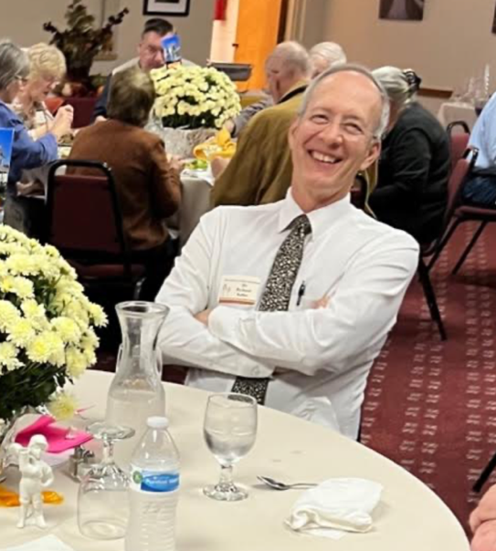

Progress best occurs as a result of that perfect combination of talent and dedication. Our mission of historic preservation is fostered by substantial efforts that include maintaining and displaying our museum, promotional activities via the “Candlelight Tour”, and by facilitating renovation of Sandusky’s historic homes and commercial buildings. Speaking for the Old House Guild board, we thank you for your interest and support.
Mission of the Old House Guild
To promote historic preservation and the restoration of significant buildings, houses, sites, and objects in the Sandusky, Ohio area. To encourage the rehabilitation and/or adaptive reuse of such properties. To accomplish these purposes by means of meetings, publications, surveys, and tours. To act as a non-profit organization and to apply for any grants that may be appropriate to further the cause of historic preservation.

Summer 2023 News for Members Page 3

Events Committee Linda Howell & Mary Truka

It is our hope that you are all enjoying this nice weather and able to spend lots of time outside.

We are always looking for new ideas for activities that would be of interest to members. In the near future you will be receiving information on our latest venture of an informative “how to” session.

Plans are in the works to host the first in a continuing series entitled “Old Houses Through New Eyes”. Tracy Hille will present “Repurposing & Redesigning Old House Treasures.” Tracy and his wife Laurie have first -hand experience of the trials, mistakes, and successes while doing a restoration of their home.

This event will take place in October (date to be determined) in the ballroom at the Boeckling Club in Sandusky and will be free and open to the public. If you know of anyone with an abundance of knowledge and experience in preservation/restoration please pass on this information to us for future workshops. Stay tuned for more details and hope to see a good crowd in October to kick off this project.

Thinking further ahead to 2024 – we are considering a July or early August Old House Guild sponsored “Garden Tour”. We are looking to all our members for help in locating some spectacular gardens within the city. If you know of a neighbor, friend, relative, or better yet if you would be willing to show off your yard please let one of us know so we can check yards out now while they are at their peak.

And again, many thanks to all who attended our Annual Spring Meeting & Dinner. Here are some more pictures for your enjoyment . . .

Summer 2023 News for Members Page 4

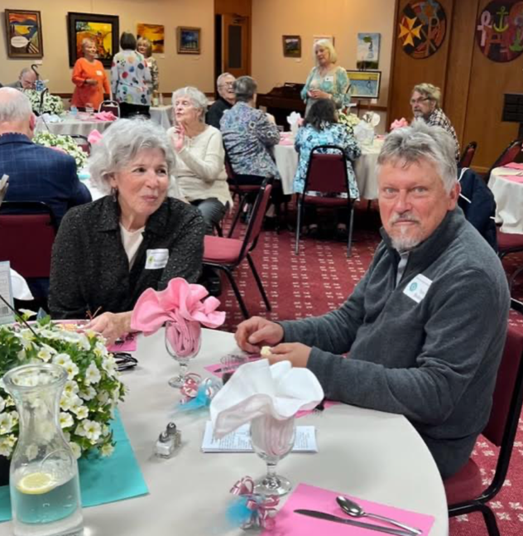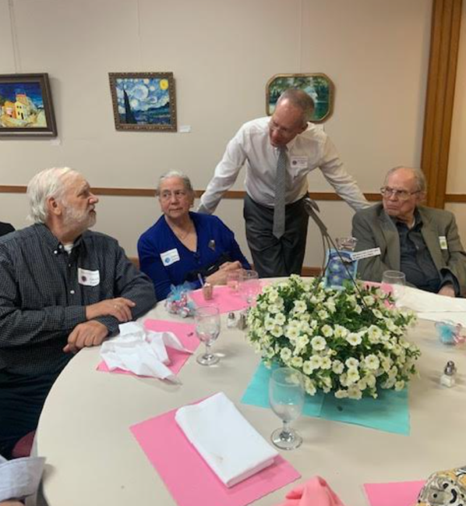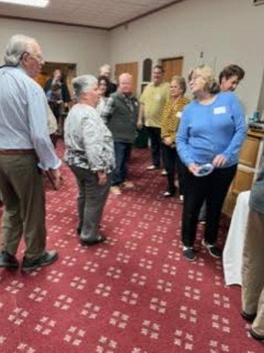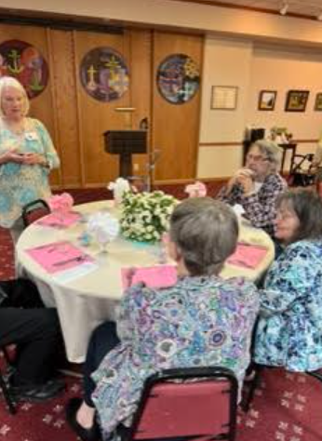

Summer 2023 News for Members Page 5

Cooke-Dorn Museum Site Manager Ed Stout

Around the Cooke-Dorn House

Things You Can Learn at the Cooke-Dorn House

The Cooke-Dorn House is a real gem to Sandusky and yet most people in the city and surrounding area know little about it, its inhabitants, or their accomplishments. Further, few can answer many, if any, of the following questions that all have a connection to the home and its furnishings.

- How many people have ever lived in this home and what all of their names are?

- Why the people who lived here were important to history and what their lasting legacy is?

- What nickname this home has from a sideline passion former owners had?

- How did this home come to be at this location today and why?

- What type of stone is the exterior of this home and how it is different from most of that stone in Sandusky?

- Why does the front and south side of the home's exterior have fine cut stone where the remainder is stucco?

- What major change occurred to the home when it was relocated to its present site?

- What are crenelations and does this home have them?

- Why did this home become a museum?

- How avant-garde was the kitchen for its time? What ten things attributed to that designation?

- What accoutrement can be found in each bathroom that is unavailable today?

- What is the detail trim on the dining room table's china and crystal that makes it rare and expensive?

- How does American seating as opposed to European seating differ for host and hostess at a dining table
Summer 2023 News for Members Page 6

- Why are certain mirrors in the home referred to as Venetian glass and what makes them different from other mirrors?

- What are vanity screens and why were they needed or used?

- Where did the phrase “cracking up” originate, referring to a person or people laughing?

- What distinguishes cranberry glass from ruby glass, and is one only lighter in color and the other darker?

- Why in the United States do we refer to certain beds as “twins” when the rest of the world calls them a single bed? What attribute was added by Americans to those beds that lasted till the mid 1960s?

If I have peaked your curiosity, you can learn all of the answers to the above questions by visiting the Cooke-Dorn House for a tour. If instead, time is not a factor and you have great patience, answers to all those questions will be given in future installments of the Guild newsletter.
-----------------------------------------------------------------------
Donation
This 1920 reclining lawn chair was recently donated to the Old House Guild by Jason Hemmer of Sandusky. It will be restored and eventually placed on display at the Cooke Dorn Museum. Many Thanks Jason!
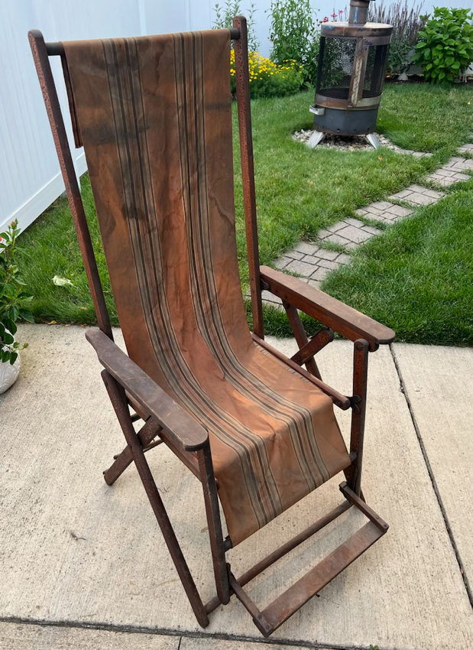

Summer 2023 News for Members Page 7

Home Preservation Laurie Hille Board Member
My husband Tracy and I live in a 1904 American Four Square brick home on Columbus Avenue. For years, I had wanted to refurbish the porch bead oak ceiling on our front porch. The wood itself was in great shape; however, the original shellac was badly crazed, black, and hard. The edge trim was gone and never replaced which made it look unfinished.
The fall of 2021 I decided to see if I could strip the finish. After only doing a very small area, I found the old shellac to be so hard that it was going to take many hours to remove, not to mention the complexity of doing that on an 8.5’ x 18.5’ surface that is over my head literally. I couldn’t afford to put that stress onto my painful finger joints. I decided I could use new wood and install it over top of the existing ceiling. I purchased prepackaged 8’ long premium cut pine bead boards from Menards. I spent several evenings staging and staining them in my garage using Minwax Red Chestnut premium oil stain, making sure the grooves were well covered. I was contemplating whether I should varnish before or after installation. I was concerned about splatter and dripping issues. A friend suggested I varnish after installation and to use a specific type of roller for varnishing in this type of an overhead situation.
Tracy and I installed the stained boards first using a brad nailer. We nailed every few inches within the grooves to hide the nails. We wanted to have a seamless look to the porch, our challenge was the boards came 8’ long but our porch was 8.5 feet wide. So instead of cutting the boards shorter and having staggered seams, we decided to center the boards and leave a 3-inch gap on each end. We added filler pieces in the 3-inch areas to keep them flush. Then we added 1 x 4-inch flat stock knot-free pine boards that we routed a ¾” radius to for a boarder detail. This was then finished off using a ¾” quarter round to complete the look.
I found the specific roller my friend suggested and applied 3 coats of varnish using Minwax fast drying clear semi-gloss polyurethane. After rolling each board, I would use a small paint brush to very lightly skim along the boards to remove any drips or bubbles that may have formed. I didn’t have to steel wool between coats.

Summer 2023 News for Members Page 8

We added a lighted two blade ceiling fan to add visual interest as well as airflow during the summer months.
I really enjoyed taking on this project and had a lot of fun with it. The outcome far exceeded how I thought it would look. Since, we have received many compliments when our family and friends have stopped in. I hope you agree how nice it turned out when you look at the pictures I am sharing here. Unfortunately, I don’t have any pictures before we started.
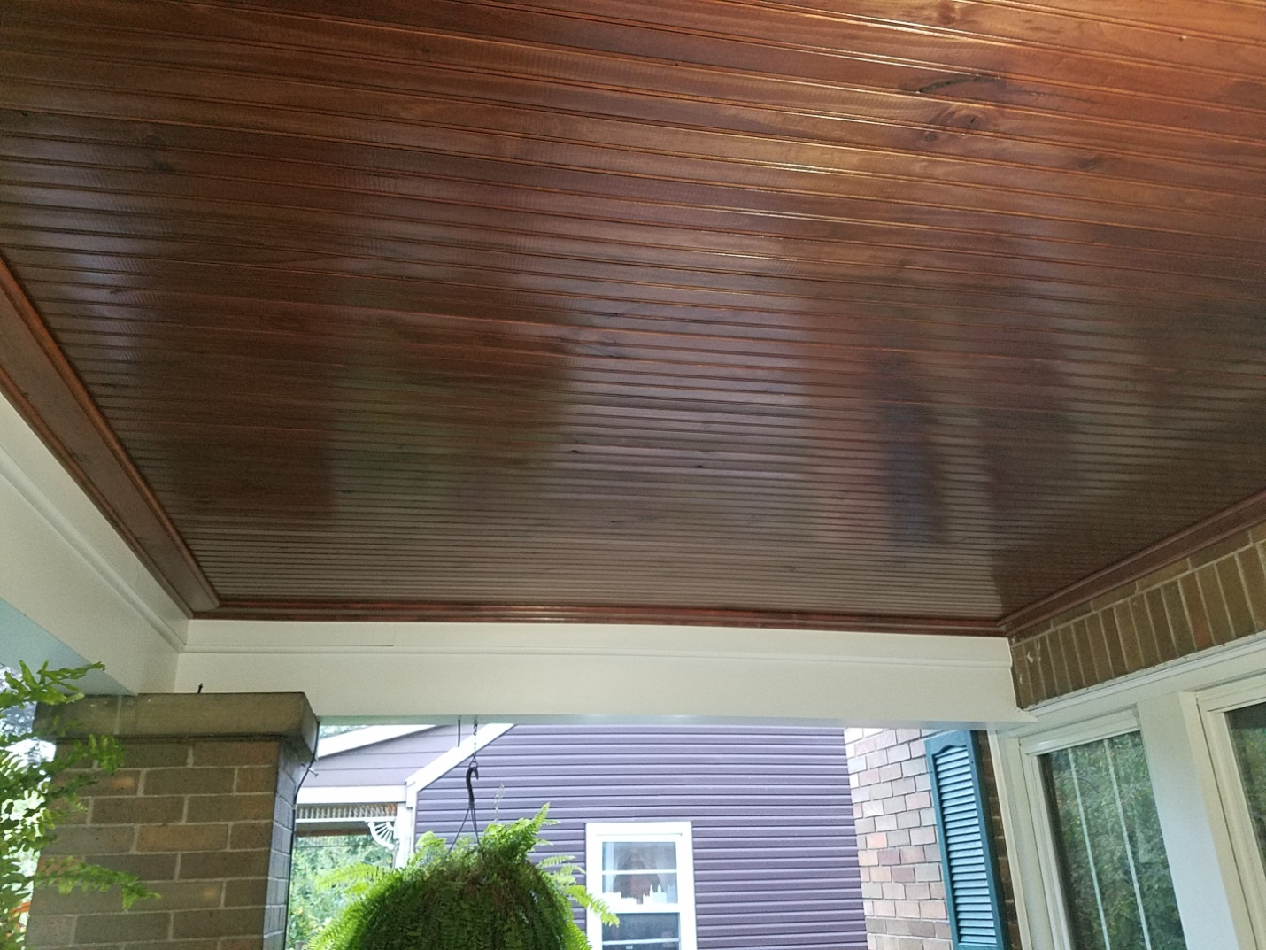
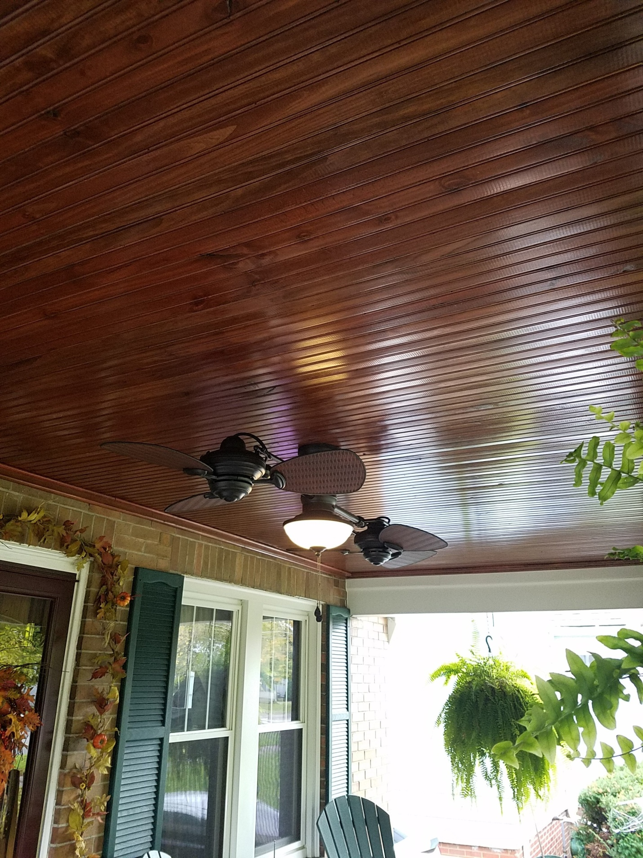

Summer 2023 News for Members Page 9

Practical Preservation Margaret Bowers See Board Member
Practical preservation is the bedrock of our community—a movement driven by those who personally wield a putty knife or engage local artisans to restore and maintain their cherished old homes. It encompasses renovation, repair, remodeling, and meticulous upkeep, all with the common purpose of preserving our small piece of our town’s heritage. Practical preservation extends to the application of sustainability principles in our home projects, ensuring a harmonious blend of tradition and contemporary living.
In the realm of modern living, we aspire to reasonable electric bills, functional spaces, and reliable Wi-Fi connections. This is where sustainability assumes its vital role. Sustainability recognizes the inseparable bond between the well-being of our homes and that of their occupants. It emphasizes the need for homeowners to consider realistic affordability in addition to craftsmanship quality when completing home projects.
Preservation maximizes the use of existing materials and infrastructure, reduces waste, and preserves the historic character of older towns and cities. The energy embedded in an existing building can be significant of the embedded energy of maintenance and operations for the entire life of the building. Sustainability begins with preservation.
When planning your next home renovation, consider beginning with sustainability projects to ensure your house’s longevity. For instance, practical preservation may suggest insulating your attic and basement. Older homes often suffer from energy leaks in these areas, making insulation crucial to protect against extreme cold or heat. Additionally, take advantage of your house's natural passive heating and cooling systems, such as utilizing shutters and window awnings for summer cooling. Trees in your landscaping can also contribute to energy conservation and allow sunlight to warm your house during colder months.
Small sustainability projects like switching to energy-efficient lightbulbs can make a significant impact on both cost savings and environmental preservation. However, when replacing certain fixtures in your home, consider reusing old or salvaged materials. You may find century-old pieces through platforms like Facebook Marketplace or estate sales, and they can match the overall aesthetic of your antique fixtures. Prioritizing the preservation of materials, components, and the building's original design, including

Summer 2023 News for Members Page 10

window and door positioning, takes precedence over solely focusing on mechanical and electrical features to enhance sustainability.
While sustainability and preservation may appear as conflicting goals, homeowners can achieve homes that are both environmentally friendly and release the historic grandeur that makes them special.
--------------------------------------------------------------
Check The OHG Website for Preservation Tips & Resources:
https://www.oldhouseguild.org/preservation-tips-and-resources/
Doors . . .

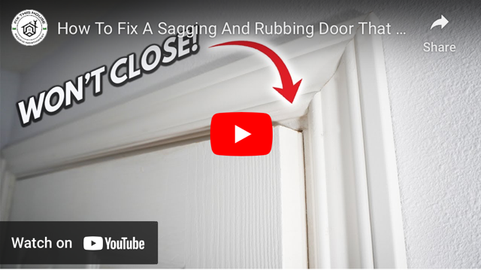

Spring 2023 News for Members Page 11
Preservation Committee Will Schram & Linda Smith

Preservation vs. Restoration
We often use these two terms interchangeably but in the world of work on historic properties they are quite different in meaning and approach.
Preservation of an historic property involves the maintenance and upkeep of existing structures. This is accomplished by utilizing appropriate methods that protect and safeguard the historically significant features so that over time, things remain intact.
Restoration refers to returning to the original condition and features of an historical structure. This includes removal of subsequent renovations and changes not original to the building, followed by a replication and installation of original, historically correct appearances.
In many cases, preservation and restoration take place at the same time. For example, a front porch could undergo preservation of original features such as railings and trim work, while wood steps that were added at a later time could be removed and restored to an original plan that included cut limestone.

Reminder
Each year the Preservation Committee selects properties in Sandusky City that have undergone substantial preservation work. If you know of any you would like to nominate for this award, please submit the address to us for consideration. Use the contact information for the Guild located at the end of the newsletter.

Volunteers for 2024 Inventory of Historic Properties
It’s not too early to volunteer for the 2024 Inventory. We are in need of folks to conduct data entry, production of mailing inserts, duplication of documents, analysis of inventory results, and training on the state inventory software. If you can give us some of your time or want to know more, give us a call, or send us an email. We need your help!

Summer 2023 News for Members Page 12

Membership Betsy Berkey Membership Chair
Margeret See has put together a membership survey to gather feedback for us to consider as we move forward to membership enhancements. Please take time to complete this anonymous survey by clicking on the following link. Many thanks. We will report our findings in the fall newsletter.
https://forms.gle/QifsTUN62LMBAGxe6
---------------------------------------------
Funding Our Work
Dr. Timothy Berkey Treasurer
Cooke-Dorn Exterior Restoration
Last month, the OHG Board approved a future reimbursement of $32,350 to the Ohio History Connection once the exterior work to the masonry has been completed and paid. This reimbursement is a portion of the overall project cost of the work to be completed sometime this year. The money was obtained through a grant written by the OHG and approved by The Randolph J. & Estelle Dorn Foundation of Sandusky in July of 2022. Ed Stout will be providing an update of this project in the fall newsletter.
Transfer of OHG CD to Online Savings Account
You may have noticed that online banking has taken hold in the U.S., accounting for around 40% of the business. Most of the major banks now offer online savings accounts that pay interest well above the current CD rates. These accounts are insured by the FDIC just like traditional passbook savings accounts. The difference is that banks can offer these at rates close to 5% compounded daily. They are able to do this by cutting their overhead costs of operating branch bank locations and utilizing online services to replace them. While some don’t like the idea of losing face to face services, the reality is higher earnings that will allow one’s money to earn at more competitive rates.
As a result of this trend, the OHG Board approved the transfer of the current CD balance that matured in July to the OHG checking account while online options are explored, and a decision is made to place the funds into an online account that earns a more competitive rate. This decision will be on the August agenda.

Summer 2023 News for Members Page 13

Want to Donate to the Old House Guild?
Very easy to do! Use your phone and scan our QR code at the left. It is also located on our website. Or, you can also write a check made out to the Old House Guild and designate if your donation is for the OHG account or the Cooke-Dorn. You can use a credit card or if you have your own Paypal account, that will work as well. Thank you for your generous contribution!

From the Editor
Betsy Berkey Editor
Thank you for the positive feedback regarding our newsletter. Our goal is to provide you with information about current Guild initiatives, upcoming activities, and most important, plans to keep us focused on our important work of preservation. Each quarter we ask the chairs and officers to submit articles to accomplish this. In addition, I reach out to others who can contribute interesting stories that I hope you find worthy of reading.
Please know that we enjoy hearing from our members if you have something interesting about the history of the city or the Guild that you would like to share, email me if you are willing to submit an article. And even if you are uncomfortable writing, you can jot down some notes or call and story-tell. I’ll take it from there and work with you on a piece that shares your story!
Betsy Berkey – betsy.w.berkey@gmail.com 440-796-2185

Note: we now post all past and present newsletters on our website so if you want to go back and read issues, they are there for your use.

Summer 2023 News for Members Page 14

Volunteer with the Old House Guild
Opportunities
Museum Tour Guide Fundraising Event Helper
Grounds Helper Historic Research Sign Painter
Historic Inventory Holiday Decorating Mailings
Candlelight Tour Helper Annual Dinner Helper Membership
And if you have any other talent to share in our organization, please let us know by calling or emailing us at the contacts listed below.

How to Contact Us
Board Members President – Richard Keller Vice President – Jack Mineo
Secretary – Linda Howell Treasurer – Timothy Berkey
Site Manager – Ed Stout Member – Mary Truka
Member – Will Schram Member – Linda Smith
Member – Laurie Hille Member – Tracy Hille
Member – Margaret See

Address: Old House Guild of Sandusky 1415 Columbus Ave. Sandusky, OH 44870
Phone: 419-627-0640 Email: info@oldhouseguild.org
Website: www.oldhouseguild.org Facebook: Old House Guild of Sandusky

Summer 2023 News for Members Page 15
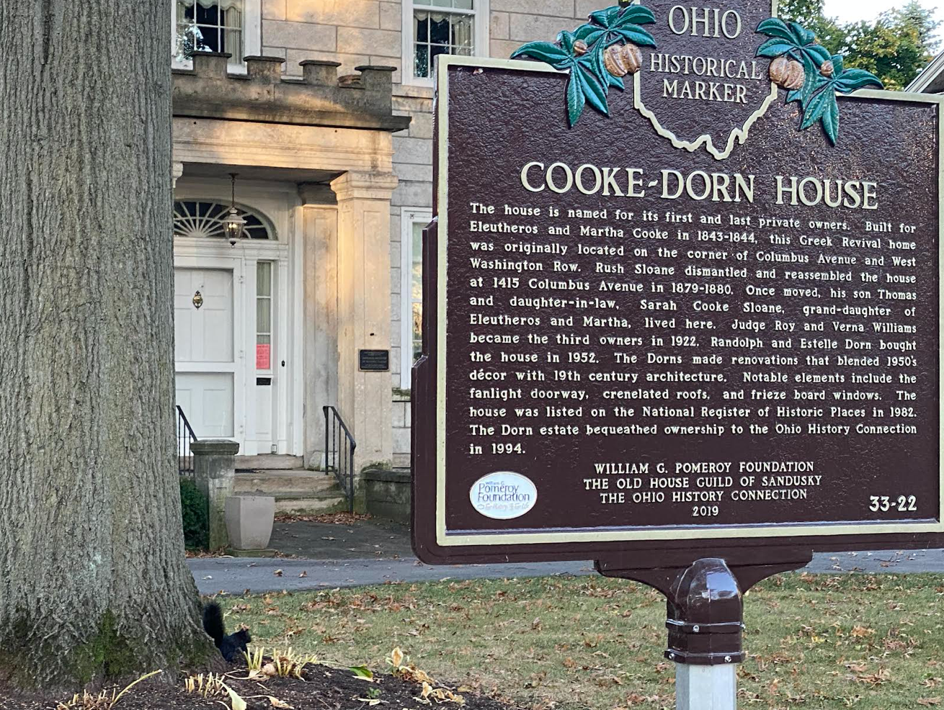

d
2023 Cooke-Dorn Hours
Wednesday – Friday
11:00 a.m. – 3:00 p.m.
Saturday
10:00 a.m.-2:00 p.m.
Special Tours can be arranged
Call Ed Stout: (419) 357-7473

